My name is Monika Kolláriková.
I am 17 years old. I live near my school in Poprad in a small flat with my parents and younger brother. In my free time I like to spend time with my friends and also I like to watch films and traveling. I love to take photos and making movies.
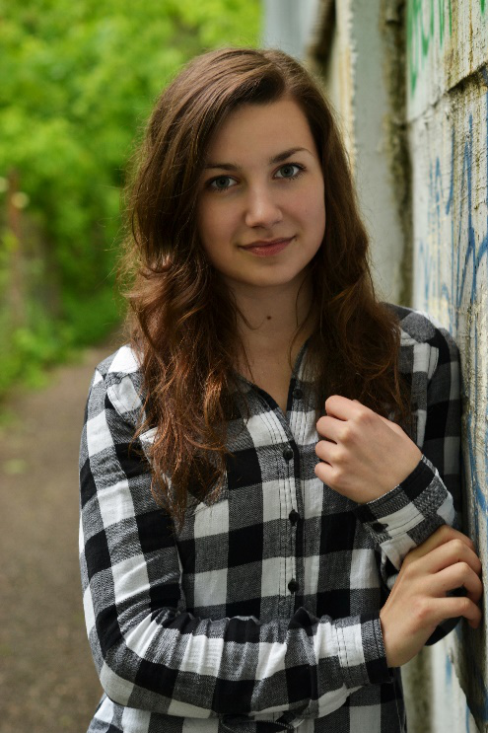
I am very interested in history and learning foreign languages.

